Above all, we detect the significant DMR by ipdmr function. Here is the summary.
Table5: Summary of DMR analysis
Bin size | N of sig-DMRs | N of DMRs
50 | 5004 | 277245
100 | 5032 | -
200 | 5115 | 277243
300 | 5171 | -
400 | 5181 | -
500 | 5195 | -
Using the first several chrunks in code DMR try 2 and dataset DMR2.data, and modify the relevant parameters like bin size can get this table

\\\
Using dataset ” resu_ipdmr.csv” (bin size 200) and code mht-plot-for-DMR.Rmd to generate mgt plot for all DMRs(not only significant DMRs)

Fristly, extract the top 10 significant DMRs and rename them as DMR1-10 to show it in the mht plot.

Then run the code to generate mht plot of p value or fdr value.
Figure 14.1 mht plot of DMR with bin size 200
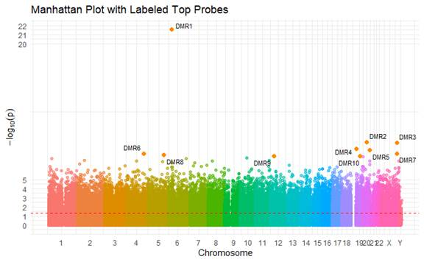
Figure 14.2 mht plot of DMR with bin size 200
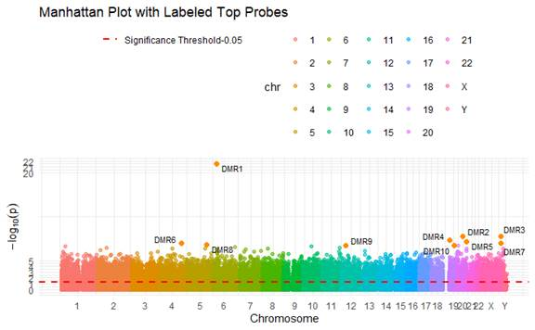
Figure 14.3 mht plot of DMR with bin size 200
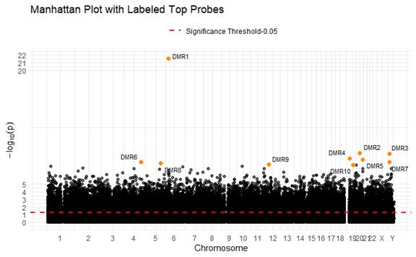
Figure 15.1 mht plot of DMR with bin size 200(fdr)
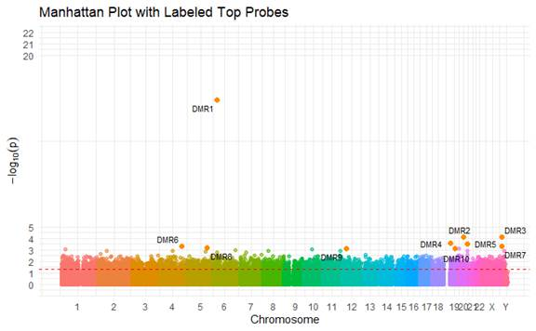
Figure 15.2 mht plot of DMR with bin size 200(fdr)
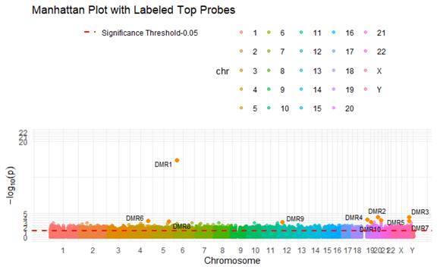
Figure 15.3 mht plot of DMR with bin size 200(fdr)
